Customisable Rummy Platform for Online Play

ANALYSIS:

Background and Stakeholders:
I run board game nights with a group of 6-7 people. We enjoy a large variety of board and card games. Through these sessions, we observed a weakness with the adaptations of card games, with rummy being a prime example of these issues. This is due to the large number of regional variations of the game, with only few variations adapted into a digital application. Many of these adaptations include mandatory gambling mechanics, which are unsuitable to casual and social games.
This context is to highlight the need for digital solutions that support both rule variations and socialisation.

Current Situation:
We explored a method to play general card games through Tabletop Simulator, a general-purpose tabletop physics simulator, which allows interaction with various board game pieces, including a deck of cards. We experimented with playing rummy, however due to its open-ended design and a user interface on memorising keyboard shortcuts, it resulted in a steep learning curve.
Setting up the game requires approximately 30 minutes, a similar amount of time went into familiarising yourself with the controls. This level of initial commitment discouraged 3 players from participating.
Furthermore, due to the open-ended nature of the simulator, it does not provide automated rule enforcement. Players are responsible, and resolve disputes manually. This becomes problematic quickly, especially when experimenting with different variations. Players felt a need for a “Cheat sheet” document open to reference during gameplay. This impacted the enjoyment, leading to the decision to not continue using the platform for Rummy.

Proposed Benefits of a New System:
A dedicated customisable rummy platform would benefit users by reducing setup time, minimising rule disputes, and removing the need for external documentation. This will be achieved through rule validation, a clear and accessible user interface, and clear configuration systems for the game.
More broadly, it allows people to share a part of their culture with friends, by introducing them to the different variations of the game, supporting social interactions.

Research:

Current Systems:
There are several ways to play Rummy. First is using a physical set of cards. Alternatively, dedicated platforms for Rummy can be used, such as RummyCircle and Rummy Palace which allow for online play. These systems will be analysed in depth to evaluate their strengths and limitations.

Physical Cards:
Through analysis of the traditional method of play, which remains the most common, insight can be gained on the core mechanics that must be replicated digitally, while also calling attention to the limitations that can be addressed in a digital platform. For a systematic analysis to take place, IPSO charts and Data Flow diagrams are used to analyse the processes, data flows, and other mechanisms of physical gameplay.

IPSO:
Input(s) | - Deck of cards.  - Player actions (drawing cards, discarding cards, laying down melds.)  - Player decisions (what cards to discard/meld, when to Lay Down.)
Process(es) | - Manual shuffling  - Manual dealing  - Manually laying off melds  - Manually drawing card  - Manual rule tracking  - Manual calculation of scores.
Storage | - Physical deck of cards  - Players hands  - Laid-down melds  - Score sheets  - Players memory
Output(s) | - Visible board state  - Current player states  - Scores  - Game winner
This IPSO reveals how the system relies on the physical actions of players, along with their experience to remember and correctly apply rules to the other players. This dependence on human processes reduces the reliability and consistency of the game, leading to disputes among players regarding the method and state of play, especially regarding different variations. Furthermore, the storage is distributed across multiple physical objects, along with player memory, creating multiple points of failure where data can be lost or corrupted. Manual validation of the multiple data stores, that are in multiple formats, could be a time consuming process. Due to the absence of automated rule enforcement, the players are required to agree on the rules beforehand, relying on knowledge and good faith, rather than automated validations.

Level 0 - High level Structure:
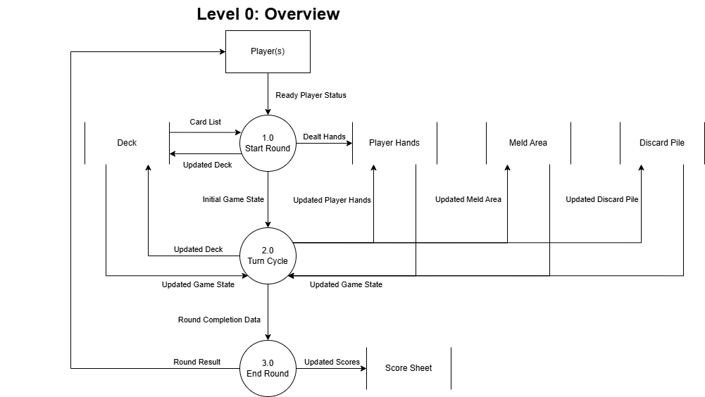
The level 0 diagram reveals the limitations that exist in the high level structure of the system, particularly the lack of a centralised validation process. As such, all data must flow between players, and they must carry out verification of the different processes done. As such, the responsibility for correct execution of rules relies on the players themselves.

Level 1 - Process Decomposition:
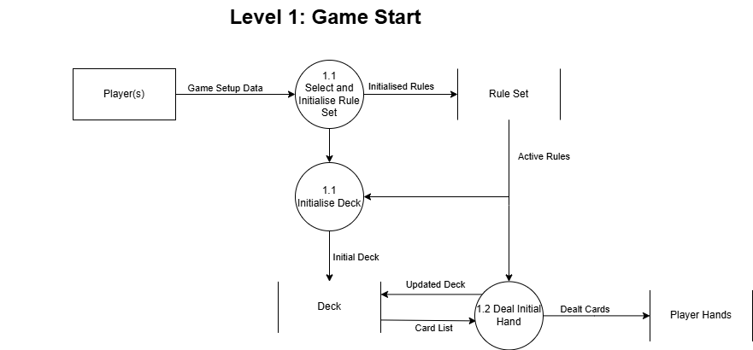
In the above decomposition of 1.0, it is revealed how the rule initialisation works for this system. Players must first agree on rules, Process 1.1 (Select and Initialise Rule Set), which are stored in the players memory (Rule Set data store). This selection creates ambiguity, as there is no persistent storage of the ruleset, and can create ambiguity in the middle of games, due to players misremembering the rules agreed upon. This is a key limitation that a digital system could address by showing the active rules during gameplay.

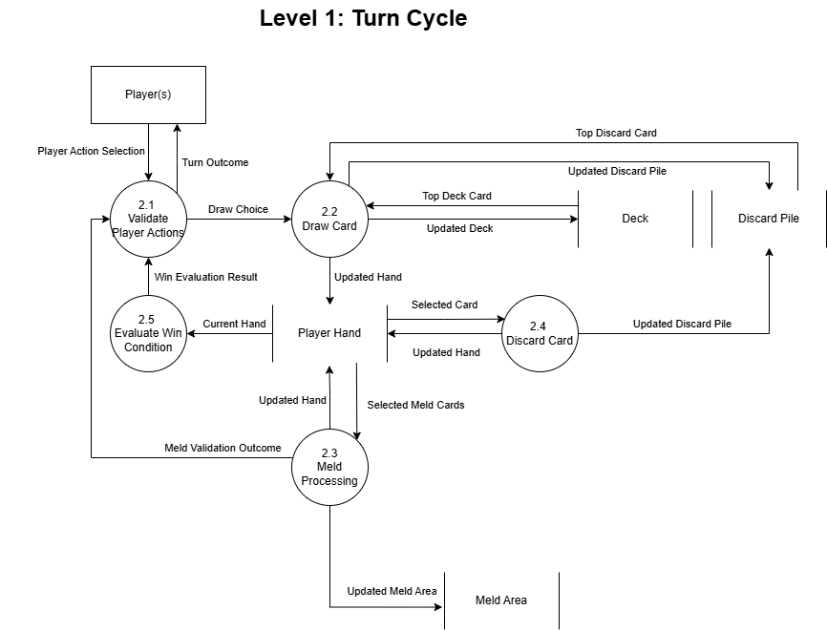
The level 1 decomposition reveals a substantial amount of hidden complexity within each process. Particularly in the 2.0 decomposition, exposes 5 subprocesses that must be validated manually each turn. Each of these validation steps is a potential point of failure, due to either bad faith actions or human error compromising the agreed upon rules.
A direct example is the Process 2.3 (Meld Processing). As melds are the most complex part of the game when verifying, as there are two different possible melds. Sets and runs have different requirements, (same rank but different suits vs same suit and ascending rank). Due to the players having the responsibility of validation, there are often moments where an error goes unchallenged. This commonly happens because players are distracted or inexperienced, and the invalid meld enters the meld area datastore permanently. In a digital system, Process 2.3 will have an algorithm to automatically check whether a meld is a valid run or set, before allowing the “Updated Meld Area” update to occur.

Error Handling and Other System Elements:
Through the DFDs, it is shown that there are no error handling flows. As such, when mistakes occur, such as a drawing mistake or an invalid meld that isn't found, there is no algorithmic process to rebuild the game state prior to the error. Instead, players are required to reconstruct the game from memory, leading into disputes and errors.
The lack of error handling is exemplified in the absence of any ‘game history’ datastore. While the score sheet datastore tracks final results, all intermediate data is lost when a new game is started. Therefore, a digital implementation could add a data store for game history/move sequence, enabling game replays and the ability to analyse games after their completion.

Player Experience and Social Dynamics:
Despite the many limitations, through the dependency on manual processes, the system offers tangible interactions between players creating a strong sense of social engagement. The personable quality inherent to physical cards is a primary reason that this remains the most popular system for playing the game. However, due to the implicit nature of the rules, with players often assuming a shared understanding, a barrier is created to new players. This can be seen when a dispute occurs, as a new player who has not internalised the rule set cannot distinguish between good and bad faith behaviour. Through a digital system you could make all rules explicit rather than assumed, even when using custom rules and variations, while also allowing social engagement to take place by using other programs for voice chat, and other methods of communication.

Online Rummy Platform (CardzMania):
CardzMania is an online card game platform, which allows for players to play a large variety of card games, including rummy. It offers many variations of card games, along with some customisable options. It also provides features such as game history and leaderboards. Throughout the following section, analysis will be done on CardzMania’s system architecture, user management, and game customisation abilities. Understanding of how this platform addresses limitations in the physical card system will also be pertinent.

System Architecture:
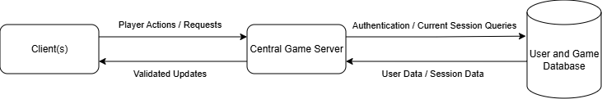

As shown above, CardzMania seems to operate on a simple client server model, where clients send actions and requests to a central game server. This central game server validates moves against the game logic loaded into memory at session initialisation, reducing cheating. Additionally, this ensures that all clients are synchronised to the current game state, as the updates are only received by clients when they are validated, and there is only one source for the game state.
However, due to the client server model, there exists a major bottleneck when it comes to scalability. Due to the centralisation of rules validation, the server load increases with the player count, as it must perform continuous rule validation for all current sessions. According to CardzMania, they have 238,000^{[1]} registered users, where if even 1% play rummy at one, (600 game states with 4 players), the server must handle continuous validation for the sessions, representing a significant load. Another issue is the fact that it acts as a single point of failure, where if the server has an issue, all games stop. To handle this load, CardzMania likely uses horizontal scaling, with multiple game servers around the world, allowing for both load balance and reduced latency for international clients, while also removing the single point of failure from the system..
A peer to peer approach could distribute the load as well as eliminate the single point of failure. However, this would introduce extra complexity and latency, as the clients must instead act as the validators. For a casual card game platform, where anti-cheat is critical, and players expect reliable gameplay,a client server model is the appropriate choice despite the more expensive infrastructure required.

Authentication and User Management:
Account creation is used as well, requiring entering a username, password, and email address. To keep the system secure, passwords are hashed before storage, such that if the database is compromised, plaintext passwords are not retrievable. The email authentication seems to be a way to mitigate spam bots from attempting to overwhelm the server with fake accounts, requiring them to be verified with an email address. When a game session begins, players are validated against the user database, where either they are compared to a user-id if signed in, or a temporary session key if using a guest account. This system ensures that both quick and easy play with a guest account is possible, while also allowing the more dedicated players to keep track of their statistics as they play the game. This dual authentication balances user acquisition and retention, as guest accounts minimize friction for casual players, not requiring them to do anything other than open the website, while the

Data Persistence and History:
Through the fact that clients can view previously played games with no limit, therefore the game database holds every game that is played. The most obvious method that this can be done is record all the player actions as a sequence of moves, as well as the rule set used. When viewing a previous game, it simply plays those moves in order in a private game session. This approach is relatively storage-efficient, as it only stores the move sequences. This is in contrast to storing the full game state after every move, which would be far more inefficient, especially for longer games. However, in longer games, going to a specific point might cause noticeable delay, due to the system having to replay all prior moves. A system could be implemented where it saves the state of the game every so often, perhaps every 20 moves. This would both be storage efficient, while not sacrificing replay performance.

Game Customisability and Rules Flexibility:
In general, CardzMania offers customisability in terms of the types of games you are able to play on the site. It handles this by offering precoded variations of the game that get loaded into memory at game state initialisation. These presets can then be fine tuned further, via a few options, such as whether or not jokers are in play, point limits, and hand sizes. This approach offers the player some limited customisability while maintaining rule validation. This offers a much higher amount of customisability compared to other other digital systems, while still taking advantage of the digital format, by using a centralised validation system.
However, the preset based approach imposes significant limitations on customization. While specific features can be toggled, more fundamental game systems cannot be altered, such as the minimum card limit for melds, or whether completed melds get added back to the draw pile. As such, this system particularly limits players who already have established house rules are unable to replicate their experience. Instead, they must settle for a “good enough” preset and options combination, compromising their experience and reducing the system's appeal for experienced players with established preferences.
In contrast, physical card play offers all the flexibility through its lack of a centralised validation system, as the players are able to agree to any modification, even in the middle of a game, no matter how unconventional. CardzMania trades this flexibility for a simpler system that is more consistent and has better cheat prevention.
An opportunity to improve this system would be to allow a truly customisable system, that allows the player to modify core rule components, such as meld size minimums, wild cards, turn structure, while maintaining the automated validation. The major challenge for this system would be how it can validate arbitrary rules consistently. CardzMania sidesteps this problem by using presets, but this represents an opportunity for innovation for a truly customisable platform.

Interviews:
Interviews were conducted with potential users of a customisable rummy platform. All participants regularly play cards physically, and have experience with digital adaptations. Therefore, they are well suited to identify the common issues and limitations with these adaptations.
Across the three interviews conducted, the questions focused on several key areas: learning curves and complexity, customisation, frustrations with current card games, social elements, and User Interface features. These interviews were conducted to gather qualitative user data, such that they may be analysed to identify the problems and in previous attempts.
The findings from these interviews are used to inform the design of the proposed solution, focusing on addressing the concerns that users have expressed.

Interview Transcript 1: Gunmay Bhalla:
The interviewee is a close friend of mine, and regularly plays a large variety of games, particularly multiplayer games with friends. As well, he frequently has a deck of cards on him, and plays physical card games regularly.
This interview was done over a google meet on the 13th of September 2025.

Faisal Mustafa: Question one (1): Do you ever feel like you’d like to play a quick game with friends but don’t have enough time to learn a completely new set of rules? Any particular game you learned recently that took much time to learn? How was the learning experience?
Gunmay Bhalla: Yes, 100%. Especially when I'm recommending a game and I know that there's a certain part where we are all going to have fun, but you know the time it will take for them to get there is just not worth it. Personally I find that games with a lot of mechanical skill like Team Fortress Two or games with a large volume of information like dungeons and dragons take the most time to learn. I still feel like I still haven’t properly learned either.
Faisal Mustafa: Question two (2): How often do you play card games with friends or family, either in person or online?
Gunmay Bhalla: I play in person with friends reasonably often, as it is the easiest way I find to get everyone in the mood to banter and talk. I usually carry a deck of cards with me most of the time though, which I acknowledge is not exactly normal.
Faisal Mustafa: Question three (3): When playing card or board games, do you usually introduce or use house rules? If yes, please give an example.
Gunmay Bhalla: Yeah, we obviously do have house rules for something. We just end up doing stuff and it becomes a house rule. Most obviously UNO and monopoly, but also when we play Dungeons and Dragons, we often just change the ruleset on a whim. Like allowing strength to intimidate as well as charisma.
Faisal Mustafa: question four: Would you be interested in an online card game platform that allows you to create and apply your own house rules in private lobbies?
Gunmay Bhalla: Yes, I would be interested in that. Especially because so often, as the version of the game you know isn't available. Though it should be a sort of “hidden” option. It would just distract from the game sometimes.
Faisal Mustafa: question five (5): What are your biggest frustrations or challenges with existing online card and board games (e.g., complexity, lack of features, poor matchmaking, paywalls)?
Gunmay Bhalla: Often the rules are not the classic version of the game. Someone will make some one specific version and if it's not what you want to play, then screw you. Secondly is that for most card games the good versions are paywalled and you can't access them.
Faisal Mustafa: Question six (6): How important are audio and visual effects (animations, sound effects, themes) to your overall enjoyment of an online card game?
Gunmay Bhalla: I feel it adds a lot to the immersion of the game. Otherwise, you just have a lot of pixels on a screen being teleported around. I find it very hard to track what’s happening without some sort of sound or visual effects. It just makes it difficult to play I feel.
Faisal Mustafa: Question seven (7): While playing online card games, what information is most important for you to see on screen (e.g., cards in hand, opponent moves, turn order, score)?
Gunmay Bhalla: I think it’s better when there is less information that the computer gives you easily, but all the information that is there should be displayed. For example, it should show the opponent's hand, like the back of it, and the number of cards in the hand should be accurate, but it shouldn’t show “x number of cards” underneath it. Like if someone has eight (8) cards, it should show that in the graphics, but it shouldn’t have like eight (8) cards in opponents hand written in the UI. It’s a double-edged sword because you don’t want someone to lose simply because they missed some information because they aren’t used to playing virtually. Maybe as an accessibility feature? Like a cheat sheet you can bring up while playing or something? Something like turn order though would need to be very explicit.
Faisal Mustafa: Question eight (8): Which devices would you most likely use to play an online card game? (e.g., smartphone, tablet, laptop, desktop)
Gunmay Bhalla: I think that desktop or laptop would be the one I’d use most often. Mostly because the only time I would use a phone or a tablet would be when I’m out and about, where I would just play with a real deck instead. Plus, card games are quite long in general.
Faisal Mustafa: Question nine (9): If you had to choose, which would you prefer:
· Online matchmaking with strangers. Why?
· Private lobbies with friends. Why?
Gunmay Bhalla: It depends on the type of card games you are playing. For example, poker I would say would prefer having online skill-based matchmaking, as it is a competitive game. But, for more communal games? I would prefer private lobbies, as the games are often very long and most fun when you are with your friends and able to banter.
Faisal Mustafa: Question Ten (10): How often do you play card games online, and what websites or applications do you use.
Gunmay Bhalla: I don’t often play card games online, but when I do it's usually on a website that hosts lots of flash games, that have some options for card games. The issue is that for most card games, like bluff or goldfish, there aren’t good online versions. If there are any, they are paywalled and not exactly worth it.

Interview Transcript 2: Alan Golovanov:
The person I am interviewing is a colleague of mine, Alan Golovanov.
This interview was done in person on the 24th of September 2025.

Faisal Mustafa: Question one (1): Do you ever feel like you’d like to play a quick game with friends but don’t have enough time to learn a completely new set of rules? Any particular game you learned recently that took much time to learn? How was the learning experience?
Alan Golovanov: Definitely, most games have a huge learning curve. The skill ceiling is too high most of the time, which completely eliminates the ability to play for most players due to the number of players who have been playing for far too long.
Faisal Mustafa: Question two (2): How often do you play card games with friends or family, either in person or online?
Alan Golovanov: Not as often as I would like, mostly due to how long it takes to set up the game. You know, sorting the deck, dealing the cards, teaching everyone the rules. It just takes a while. Also getting everyone together is just a massive pain.
Faisal Mustafa: Question three (3): When playing card or board games, do you usually introduce or use house rules? If yes, please give an example.
Alan Golovanov: Definitely, definitely. I think house rules definitely make the games more fun. If it is implemented right, they'd definitely change the game in a more positive way. The main time I add house rules is for games like UNO, stacking cards and things like that.
Faisal Mustafa: Question four (4): Would you be interested in an online card game platform that allows you to create and apply your own house rules in private lobbies?
Alan Golovanov: Yeah, definitely. Uno does this, but not well. It's definitely hard to play and use the custom rules. They definitely propagate their own idea of the game, which kind of shows that most games nowadays have a bias towards their own creator's opinion. And I think that the players should be able to decide what the rules are.
Faisal Mustafa: Follow-up: If I may ask, what version of Uno are you talking about?
Alan Golovanov: Uh, the android one, you can just download it. There's some changes you can make to the rules, but most of the time it's just variations of rules they made. Not house rules.
Faisal Mustafa: Question five (5): What are your biggest frustrations or challenges with existing online card and board games (e.g., complexity, lack of features, poor matchmaking, paywalls)?
Alan Golovanov: Um, again, a big learning curve. And, um, just overall, I think the UX is a big issue. Uno lags a lot. I'm using Uno as my main example here. Uno lags a lot. It needs a specific OS to run, which limits people from being able to access it. Plus, there's just not a lot of options overall. Yeah, lack of features is what I would say.
Faisal Mustafa: Question six (6): How important are audio and visual effects (animations, sound effects, themes) to your overall enjoyment of an online card game?
Alan Golovanov: The visuals are definitely important. Like, I think just the basics they have to like function well, more than look good. I just want it to be smooth. But audio, I would say for audio… as long as you get a good sounding audio that's satisfying to your ears, you don't need to invest into a lot of audio, you know? It’s important, but not that important to enjoy the game.
Faisal Mustafa: Question seven (7): While playing online card games, what information is most important for you to see on screen (e.g., cards in hand, opponent moves, turn order, score)?
Alan Golovanov: The most important information I need to know? I'd imagine it would be nice to know how many cards are left in the deck, you know? For some games it's important to know, it's just to have a feel for it. It has to be implemented in a way that's visually pleasing as well, not just a giant number, an implementation so that you can somewhat see them, it’s specific to the game. I think turn order would be important to know, as well a s obviously the number of cards in people’s hand.
Faisal Mustafa: Question eight (8): Which devices would you most likely use to play an online card game? (e.g., smartphone, tablet, laptop, desktop)
Alan Golovanov: Probably a laptop or a phone. Realistically, a laptop or desktop, because it's much easier to access. For a quick game, I'd like to be able to just click out of my tab that I'm working on, play a game with my friends, and call it a day, get back to work.
Faisal Mustafa: Question nine (9): If you had to choose, which would you prefer:
· Online matchmaking with strangers. Why?
· Private lobbies with friends. Why?
Alan Golovanov: I'd say a mix of both, you know? Most probably I would use private lobbies more because with card and board games, most of the enjoyment comes from talking with your friends as you play the game. I would use online matchmaking sometimes, just because if I'm bored it's convenient, but otherwise I would use private lobbies.
Faisal Mustafa: Question ten (10): How often do you play card games online, and what websites and applications do you use?
Alan Golovanov: I've answered this a bit.I play Uno sometimes on my phone. It's comfortable on my phone, easy to set up. Adding a friend is so annoying though. It takes so long. You have to send a link to the person instead of just searching for a username, because the usernames are always so long.

Interview Transcript 3: Abiel Tenorio:
The person I am interviewing is a friend of mine, Abiel. He is no stranger to complex card and board games, and equally so for weird online versions, as an avid dungeons and dragons player. As such, he is used to more demanding and complex initial user experiences.
This interview was done in person on the 25th of September 2025.
Faisal Mustafa: Question one (1): Do you ever feel like you’d like to play a quick game with friends but don’t have enough time to learn a completely new set of rules? Any particular game you learned recently that took much time to learn? How was the learning experience?
Abiel: No. Most of the time me and my friends have enough free time where the learning curve doesn’t really matter. We can just hop on and spend a whole day learning without it really affecting anything. I think the strongest learning curve I’ve gone through recently is the card game Magic: The Gathering. Just because it is such an old game with so much to learn.
Faisal Mustafa: Question two (2): How often do you play card games with friends or family, either in person or online?
Abiel: I play a bit, not as much as I want to, but I would love to play more card games with my friends or family. I would most of the time like to play in person, but most of the time that’s not possible.
Faisal Mustafa: Question three (3): When playing card or board games, do you usually introduce or use house rules? If yes, please give an example.
Abiel: Most of the time yes, such as with UNO, with 07 rulings and stacking. Monopoly as well, with how you can buy land and houses.
Faisal Mustafa: Question four (4): Would you be interested in an online card game platform that allows you to create and apply your own house rules in private lobbies?
Abiel: I feel like I would like it, as I like customizing things in general. User customizability is good, but if I was so concerned with it, I would just use something like Tabletop Simulator where it has infinite customizability.
Faisal Mustafa: Question five (5): What are your biggest frustrations or challenges with existing online card and board games (e.g., complexity, lack of features, poor matchmaking, paywalls)?
Abiel: I don’t have many, mostly because I don’t play many online card games or board games, except Dungeons and Dragons. Maybe if i was to point to something it would be the friction of actually starting to play. Dungeons and Dragons has this issue if you try to play with an online tabletop.
Faisal Mustafa: Question six (6): How important are audio and visual effects (animations, sound effects, themes) to your overall enjoyment of an online card game?
Abiel: For an online card game, I wouldn’t rank the sound effects and such that highly, because it doesn’t change much in the end. It’s not like a horror game where the atmosphere is incredibly important.
Faisal Mustafa: Question seven (7): While playing online card games, what information is most important for you to see on screen (e.g., cards in hand, opponent moves, turn order, score)?
Abiel: For a card game, it'd be just the basic information of the game. Turn order, the steps in a turn, what can be played, what can’t, score, et cetera.
Faisal: Question eight (8): Which devices would you most likely use to play an online card game? (e.g., smartphone, tablet, laptop, desktop)
Abiel: Either a desktop or laptop. Maybe a tablet? Not a smartphone or a console though, it just isn't made for that.
Faisal Mustafa: Question nine (9): If you had to choose, which would you prefer:
· Online matchmaking with strangers. Why?
· Private lobbies with friends. Why?
Abiel: It depends on the game obviously. For most games I would choose online matchmaking because it allows more progression and consistent playing. There are a lot of games though that would be better with friends, especially if it is more than 2 people.
Faisal Mustafa: Question ten (10): How often do you play card games online, and what websites and applications do you use?
Abiel: No, I don't usually play card games online. The most I have is Magic: The Gathering Arena and some uno on random websites.

Interview Summaries:
From the interviews, some potential users with different desires are revealed. Gunmay frequently plays using physical cards, Alan is focused on convenience, while Abiel is more of an enthusiast, willing to play more complex games.
More specifically, an issue identified by the interviewees was the lack of flexibility in existing online card games, especially regarding rule variations. As Gunmay put it, “the version of the game you know isn't available”. As well, Alan describes the options given to him in Uno were "just variations of rules they made. Not house rules.".
However, users expressed concern that could negatively impact the learning curve of the game, especially for casual players. Gunmay suggests customisation as a “Hidden option”, to avoid turning away casual players. Abiel instead mentions that players who want extreme customisability will use a platform such as Tabletop Simulator.
Setup friction is another issue that was experienced by multiple people is the setup friction. Alan expressed this for physical cards, "sorting the deck, dealing the cards, teaching everyone the rules". As such, a digital platform must provide a streamlined game setup and clear explanations of the rules to minimise the friction.
In terms of platform preferences, all interviewees answered that the primary platform they would use would be a desktop or laptop, citing the longer sessions present in online games, as well as having better interfaces compared to mobile devices. However, they all expressed technical frustrations with the current systems. This included performance issues, along with platform dependency issues, such as when Alan mentioned “Uno lags a lot. It needs a specific OS to run, which limits people from being able to access it.”. Further, Alan expressed annoyance with the friending system in UNO, where “Adding a friend is so annoying...”, as it requires a link be sent to the other client, instead of it working in the app.
As well, social experience was highlighted to be particularly important for this genre of game. All of the interviewees called attention to the importance of social interaction in card games, as Alan puts it, “most of the enjoyment comes from talking with your friends as you play the game”. Furthermore, all interviewees preferred private lobbies over public matchmaking. As such, easy player interaction must be a focus of the system. With streamlined social features, instead of a competitive ranking system.
In terms of the user interface and experience, the interviewees expressed a want for information to be displayed implicitly, rather than explicitly through text. As Gunmay mentions, "it should show the opponent's hand, like the back of it, and the number of cards in the hand should be accurate, but it shouldn't show 'x number of cards' underneath it." . The reason this method was preferred was to maintain the tactile feel of physical cards, requiring players to observe and still do some parts manually.
However, it was also mentioned that this could be a slight barrier to players unfamiliar with digital card games, as they could miss digital information. As such, a solution given by Gunmay was "An accessibility feature? Like a cheat sheet you can bring up while playing or something?". However, it was also expressed that some information would need to be explicit, such as turn order.]
Regarding animations and sound effects, there was a spectrum of answers given, with Gunmay stressing its importance, "I find it very hard to track what's happening without some sort of sound or visual effects. It just makes it difficult to play.". However, Abiel and Alan considered it less critical, saying that it “doesn’t change much in the end”.

Objectives:
Through the current system analysed and the interviews conducted, clear objectives have been identified such that the game is a minimum viable product.
- Central Validation System:
In order to address the issues found in the physical card system, where players must rely on memory and their interpretation of rules, creating disputes over validity, a central validation system would be used. This system would programmatically enforce rules, and prevent invalid actions from entering the game state, eliminating the largest issue with physical card play.
Performance Criteria:
- Perfect accuracy in detecting the validity of moves during testing
- The system can handle all standard rummy rules, while allowing for custom rule configurations that can still be used to validate moves.
- Error messages must be present when a move is invalid, such as "Cannot meld 7♠-8♥-9♠: mixed suits"
- Rule Validation must occur within 100ms per move

- Client-Server Network Architecture:
As found in the analysis of CardzMania, a client-server system is the most efficient system for communication. This is because a client server model provides a single authoritative source for current and previous game states, removing the synchronization and difficult communication from a decentralised system. This ensures that all clients see identical information.
Performance Criteria:
- All clients must be synchronised to the updated game state within 800ms
- The system supports multiple concurrent game sessions.
- Disconnected clients can reconnect within an allotted time without data loss.

- Account Creation and Authentication:
Through the analysis of CardzMania, it is revealed that users want to track their games. As well, all interviewees expressed a want for private lobbies and friends lists. This would be addressed through account creation.
Performance Criteria:
- Account creation completes in under 30s for the user.
- Passwords must be hashed, and must be done quickly. (Under 500ms)
- Users can search and add friends through usernames.
- Email verification must be used to deter spam booths.

- User Interface Design:
Analysis of the interviews identified the preferences for UI design, a preference that balances implicit and explicit information, depending on the importance of the information and the accessibility features chosen. This would address the want for tactile quality while allowing for clear information display
Performance Criteria:
- The default UI should display information implicitly
- Optional Accessibility toggle to be done in 2 actions
- Turn order and other critical information to be clearly visible

- Game Rule Customisation:
A system to modify the ruleset granularly had been shown through the interviews conducted, with Gunmay raising a complaint that “the version of the game you know isn’t available”. This was also mentioned by Alan, as developers offered "variations of rules they made. Not house rules".
Performance Criteria:
- Custom rule configurations to named and saved to a local account
- Rules to be loaded from local account in under 5 seconds
- Generate a shareable code to load a ruleset, e.g. "RMY-A7B3-X9K2"
- The system validates that rules are valid through detecting and preventing contradictory rule combinations, such as the minimum meld size being more than the maximum meld size.
- Rule Configuration UI should be simple, with options split up into recognisable categories in the UI.
- Allow customisation of core rules, such as meld restrictions and requirements, Ace positioning, etc.
- Allow customisation of basic rules, such as scoring system, joker count, discard pile reuse, etc.

Appendix:

Glossary:
Rummy: A popular card game, featuring melds, laying off, and drawing from the Draw Pile and the discard pile.
Draw pile: The draw pile consists of a collection of face down cards which players draw from during their turn. Specificities depend on the selected rule set.
Discard pile: The discard pile consists of a collection of face down cards which is formed from player discards. Players may optionally draw from it. Specificities depend on the selected rule set.
Meld(s): A meld is a collection of cards that are validated by the active rule set, typically to reduce a player's hand, categorised into sets and runs.
Joker(s): A wild card that represents itself into another card when forming melds. Specificities depend on the selected rule set.
Ace(s): A card that can be treated as high, low, or both depending on the selected rule set.
Set(s): A category of melds where the consisting cards are the same rank but different suits. Specificities depend on the selected rule set.
Run(s): A category of meld where all cards are sequential and the same suit. Specificities depend on the selected rule set.
Laying off: Adding a card from the players to meld on the table. If it reaches the maximum number of cards for the type of meld, no more cards may be added.

Bibliography:
[1] CardzMania 2026, CardzMania - Play 50+ card games online with up to 12 players. Available at: https://www.cardzmania.com/ (Accessed: February 12, 2026.)

